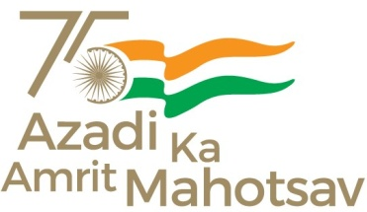
केन्द्रीय विद्यालय,सुरदा
KENDRIYA VIDYALAYA SURDA
पता+पो– सुरदा,घाटशिला At+P.O–Surda,Ghatsila
जिला–पूर्वी सिंहभूम,झारखंड Dist.–East Singhbhum,Jharkhand
पिन/PIN –832303 दूरभाष/Ph.(06585-295511)
वैबसाइट/website- https://surda.kvs.ac.in/ ईमेल/e-mail–kvsurda1191@gmail.com
KV Code – 1191,Stn Code – 123 CBSE School No.69512,CBSE Affiliation No.3400026
फ.1191/के.वि-सुरदा/2023-24/ दिनांक: 15.06.2023
IMPORTANT NOTICE
As per the order of Jharkhand Government the classes from I to VIII will be suspended till 17th June 2023 where as the classes for class IX to XII will re-open on 17th June 2023 after summer vacation.

Bishwanath Hansdah
PRINCIPAL

